CSA05: DATABASE MANAGEMENT SYSTEMS-ASSIGNMENT
ER Diagram Question: Traffic Flow Management System (TFMS)

Entities and Attributes:
• Roads
- • RoadID (PK)
- RoadName
- Length (in meters)
- SpeedLimit (in km/h)
• Intersections
- • IntersectionID (PK)
- IntersectionName
- Latitude
- Longitude
• Traffic Signals
- • SignalID (PK)
- SignalStatus (Green, Yellow, Red)
- Timer (countdown to next change)
- IntersectionID (FK) (References Intersections)
• Traffic Data
- • TrafficDataID (PK)
- Timestamp
- Speed (average speed on the road)
- CongestionLevel
- RoadID (FK) (References Roads)

Relationships:
• Roads and Intersections
- • One-to-Many relationship: A road can connect to many intersections, but each intersection connects to one road.
- Optionality: A road must connect to at least one intersection, but an intersection must belong to exactly one road.
• Intersections and Traffic Signals
- • One-to-Many relationship: An intersection can host multiple traffic signals, but each traffic signal belongs to one intersection.
- Optionality: Each intersection may have multiple traffic signals, but each traffic signal must belong to one intersection.
• Roads and Traffic Data
- • One-to-Many relationship: A road can have multiple traffic data entries, but each traffic data entry belongs to one road.
- Optionality: A road can have multiple traffic data entries, but each traffic data entry must belong to one road.
Cardinality and Optionality Constraints:
- Roads to Intersections
  - Many-to-Many (mandatory for both entities)

- Intersections to Traffic Signals
  - One-to-Many (mandatory for intersections, optional for traffic signals)

- Roads to Traffic Data
  - One-to-Many (mandatory for roads, optional for traffic data)

LOGICAL MODEL :
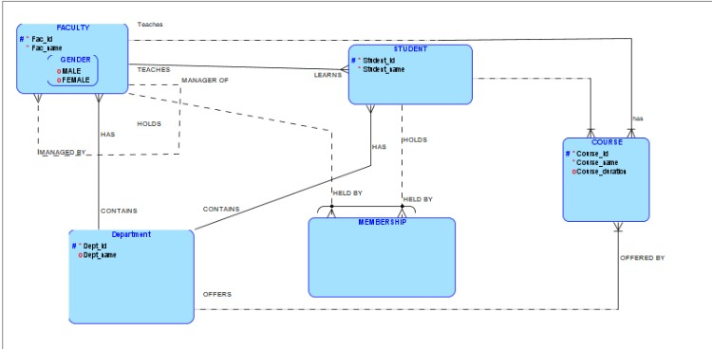
RELATIONAL MODEL

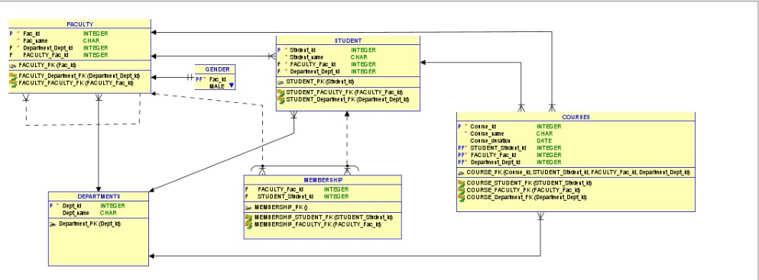

Justification Document
• Normalization
- 1NF (First Normal Form):
  - Ensure that each attribute contains only atomic (indivisible) values.
  - Each table has a primary key to uniquely identify rows.
- 2NF (Second Normal Form):
  - Ensure that all non-key attributes are fully functionally dependent on the primary key.
  - Remove partial dependencies, i.e., no non-key attribute should depend on a part of the primary key.
- 3NF (Third Normal Form):
  - Ensure that all attributes are only dependent on the primary key.
  - Remove transitive dependencies, i.e., no non-key attribute should depend on another non-key attribute.
• Scalability and Real-Time Data Processing
- • The design ensures that real-time traffic data can be efficiently stored and retrieved by linking Traffic Data to specific Roads.
- The relationships between entities are clearly defined, enabling efficient query execution for route optimization and traffic signal control.
- By normalizing the data, we minimize redundancy, ensuring efficient data storage and retrieval, which is crucial for real-time traffic management.
• Efficient Traffic Management
- • The Traffic Signals entity is linked to Intersections, allowing adaptive control algorithms to dynamically adjust signal timings based on real-time traffic flow and congestion data.
- Historical traffic data stored in Traffic Data can be analyzed to improve future traffic planning and congestion management.

How the ER Diagram Supports TFMS Functionalities:
• Road Network Management
- Entities Involved: Roads, Intersections
- Support:
  - The Roads entity stores essential information about each road, including its name, length, and speed limit.
  - The Intersections entity helps in managing key points where roads meet, identified by unique IDs and geographic coordinates.
  - The one-to-many relationship between Roads and Intersections ensures that each road can connect to multiple intersections, enabling efficient management of the road network.
• Intersection Control
- Entities Involved: Intersections, Traffic Signals
- Support:
  - The Intersections entity maintains data on intersections, crucial for controlling and managing traffic at these points.
  - The Traffic Signals entity is linked to Intersections, allowing the system to manage signals at each intersection.
  - The one-to-many relationship between Intersections and Traffic Signals ensures that each intersection can have multiple signals, supporting complex traffic control at busy junctions.
• Traffic Signal Management
- Entities Involved: Traffic Signals, Intersections
- Support:
  - The Traffic Signals entity includes attributes for signal status (Green, Yellow, Red) and a timer for countdown to the next change, allowing for precise control and timing adjustments.
  - By associating signals with intersections, the system can manage and optimize signal timings based on real-time data and traffic patterns.
• Real-Time Data Integration
- Entities Involved: Traffic Data, Roads
- Support:
  - The Traffic Data entity collects real-time data from sensors, including speed, congestion level, and timestamps.
  - The relationship between Traffic Data and Roads ensures that real-time data is associated with specific roads, enabling accurate monitoring and response to traffic conditions.
• Route Optimization
- Entities Involved: Traffic Data, Roads, Intersections
- Support:
  - Real-time and historical traffic data stored in the Traffic Data entity provides the necessary information for route optimization algorithms.
  - The relationships between roads, intersections, and traffic data allow the system to calculate optimal routes based on current traffic conditions, enhancing transportation efficiency.
• Traffic Signal Control
- Entities Involved: Traffic Signals, Traffic Data, Intersections
- Support:
  - The Traffic Signals entity's linkage to Intersections and Traffic Data enables adaptive control algorithms to adjust signal timings dynamically.
  - By leveraging real-time traffic data, the system can modify signal states to manage traffic flow and reduce congestion.
• Historical Analysis
- Entities Involved: Traffic Data, Roads
- Support:
  - Historical traffic data stored in the Traffic Data entity allows for in-depth analysis of traffic patterns and trends.
  - The relationship between Traffic Data and Roads provides a comprehensive dataset for planning future improvements and traffic management strategies.

-OVIYA.M
192321117
Btech-IT

